

American International University- Bangladesh

CSC 3215: Web Technologies

CO2 and CO4 Evaluation

Finished Project Report

Fall 2022-23

**Project Title:** MotorHub Store

**Section:** A

**Group No:** 02

|  |  |
| --- | --- |
| Student Name | Student ID |
| MD.Forhadul Islam | 20-42091-1 |
| MD.Shohaibur Rahman | 20-42424-1 |
| Amit Podder | 20-42273-1 |
| Nabila Chowdhury Joya | 20-42268-1 |

**Project Description:**

One of the most important aspects of having our website is we have direct access to our customers by email addresses, and contact numbers we can send them email marketing promotions, offer discounts, and announce new products. Getting repeat buyers is much more difficult in a marketplace because we don’t have direct access to our customers. This gives opportunities to provide good customer service and promote. Not only do we have records also know what they bought, how much they spent, and what they are interested in. You can use this information to influence and suggest future purchases and make a good forecast plan for the future of the company. The most telling impact of our project has been the ease of business continuity in the face of a global pandemic that has otherwise led to the closure of several businesses, when you open a physical store, your capital layout and day-to-day expenses are huge rent space, spend money on the decor, then you have paid employees, and so on. However, with an online store, only need to spend to get our website up and running, and for hosting. With an online storefront, our potential customers can be anywhere in the world, provided you are willing to ship. we are not limited by geographical borders. our site can be accessed almost anywhere in the world.

**Project Folder Structure:** In our project, we used the MVC structure.

**Admin:**

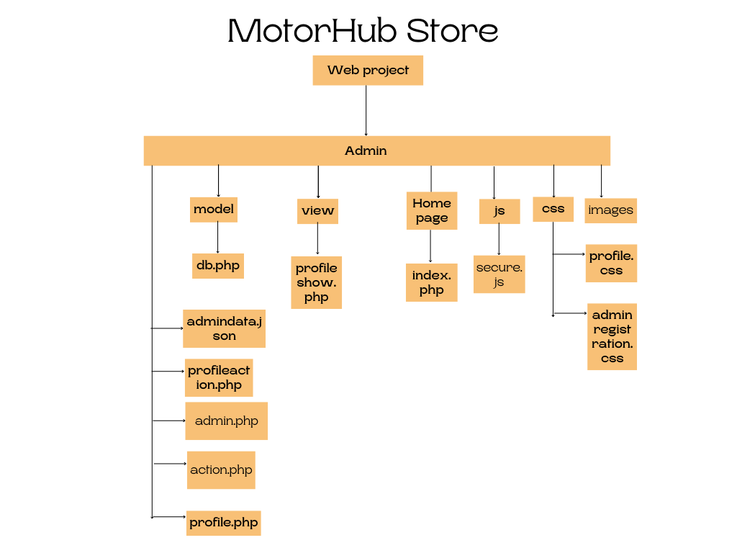

**Manager:**

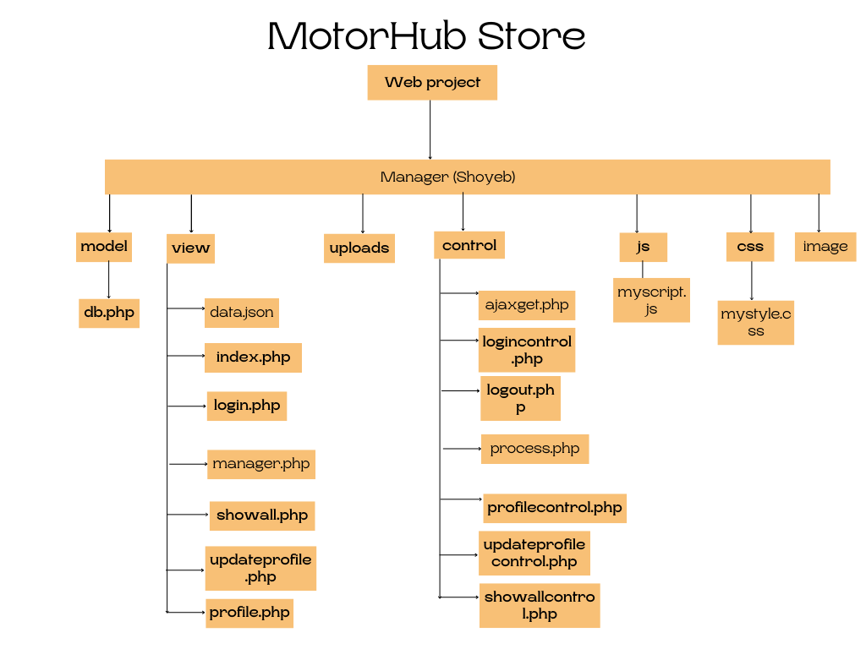

**Customer:**

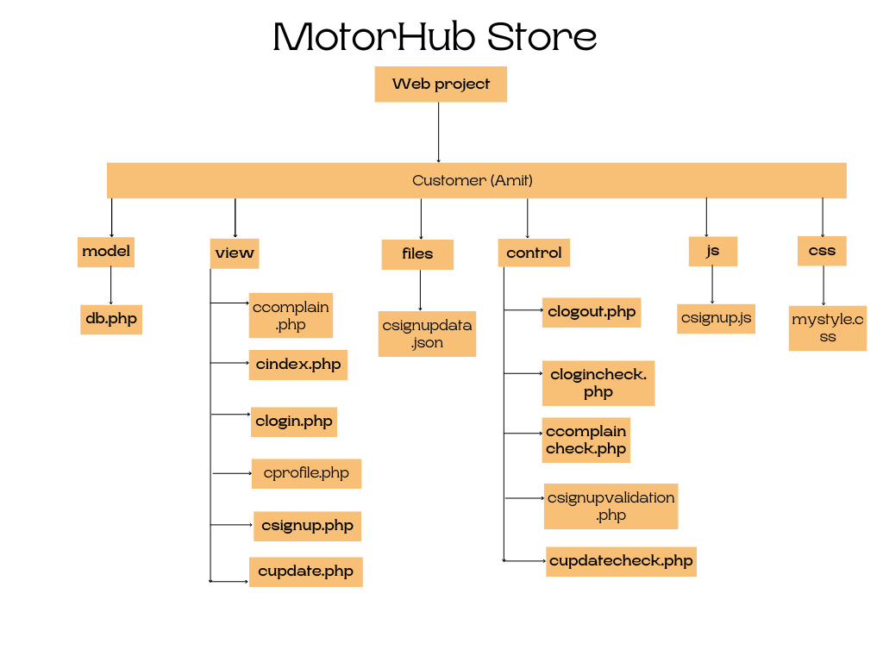

**Delivery Man:**

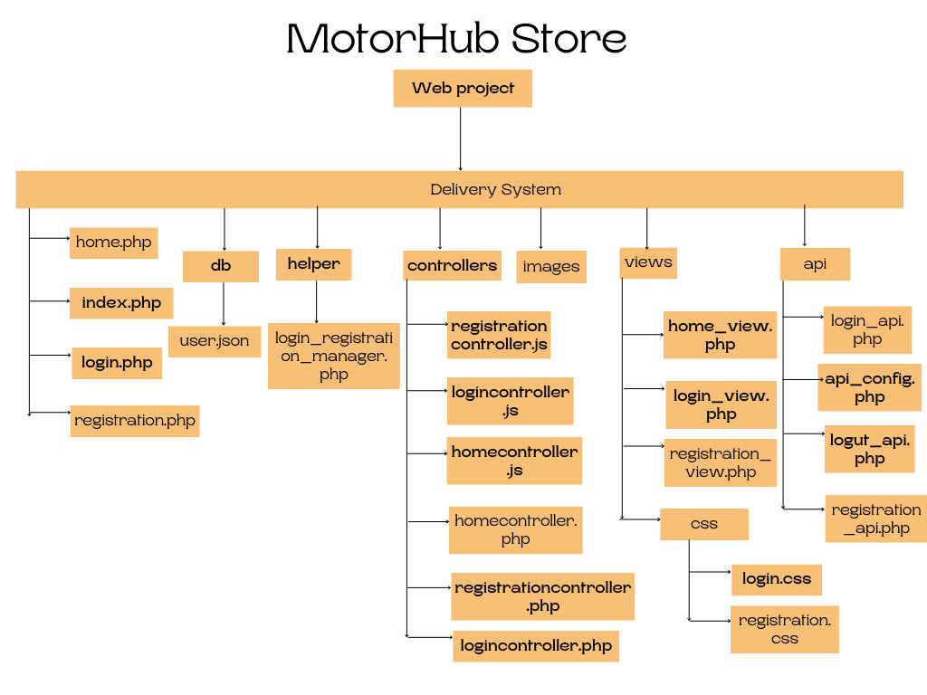

**Core Modules Of The Project:**

File Directory: Admin -> action.php

if(empty($_POST['fpass']) &&  empty($Cpassword))

               {

                   $passError = "*";

                   $hasError=1;

               }

               else

                 {

                   if($Cpassword == $password)

                  {

                   if( !$Uppercase || !$Lowercase || !$Number || !$SpecialChar || strlen($Cpassword) < 6)

                   {

                    $passError = "Password should be minimum 6 digit and Include specialChar/number/upper & lower case";

                    $hasError=1;

                   }

                    else  { $passError = "";

                             $hasError=0;

                          }

                  }

                  else

                  {

                  $passError =" Password not match";

                  $hasError=1;

                  }

                }

File Directory: Manager(shoyeb) -> js ->myscript.js

function getuser()

{

    var name=document.getElementById("search").value;

var myobj= new XMLHttpRequest();

myobj.onreadystatechange = function (){

if(this.readyState==4 && this.status==200)

{

  document.getElementById("print").innerHTML=  this.responseText;

}

};

  myobj.open("GET","http://localhost/secA/control/ajaxget.php?searchdata="+name,true);

  myobj.send();

}

File Directory: Admin -> JS -> secure.js

 function emailcheck()

 {

    var y=document.getElementById("fmail").value;

    if(y.indexOf('@')<=0 || y.charAt(y.length-4)!='.')

    {

        return false;

    }

    else

    {

        return true;

    }

 }